**BACS 2003**

**BMCS 2003**

**BACS 3074**

**Artificial Intelligence**

Tutorial Book

Lecturer/Tutor:

**Registered Student**

|  |  |  |
| --- | --- | --- |
| No | Name | Email |
| 1 |  |  |
| 2 |  |  |
| 3 |  |  |
| 4 |  |  |
| 5 |  |  |
| 6 |  |  |
| 7 |  |  |
| 8 |  |  |
| 9 |  |  |
| 10 |  |  |
| 11 |  |  |
| 12 |  |  |
| 13 |  |  |
| 14 |  |  |
| 15 |  |  |
| 16 |  |  |
| 17 |  |  |
| 18 |  |  |
| 19 |  |  |
| 20 |  |  |
| 21 |  |  |
| 22 |  |  |
| 23 |  |  |
| 24 |  |  |

# Tutorial 1

1. Who is the father of A.I.? Describe the reason why he was recognized so. ()

|  |
| --- |
| **Answer:** |

1. Identify one key event or major achievement of A.I. development in the year of
2. 1960-1969 ()
3. 1970-1979 ()
4. 1980-1989 ()
5. 1990-1999 ()
6. 2000-2009 ()
7. 2010-2019 ()

|  |
| --- |
| **Answer:** |

1. Name an artificial intelligence application that is created by a Malaysian company. Briefly describe its A.I. functions. ()

|  |
| --- |
| **Answer:** |

1. Differentiate between the following, then provide an example for each type of system.
2. Systems that think like humans. ()
3. Systems that act like humans. ()
4. Systems that think rationally. ()
5. Systems that act rationally. ()

|  |
| --- |
| **Answer:** |

1. Design a simple architecture of the following agents. You must clearly illustrate how the agent should react to the necessary input and produce output.
2. Agent of an automated class scheduling system. ()
3. Agent of an intelligent air-conditioning system. ()
4. Agent of autonomous driving car. ()

|  |
| --- |
| **Answer:** |

# Tutorial 2

Instead of asking, "Can machines think?", Alan Turing said we should ask, "Can machines pass a behavior test for intelligence?". Turing predicted that by the year 2000, a computer could be programmed to have a conversation with a human interrogator for five minutes and would have a 30% chance of deceiving the interrogator that it was a human. (Negnevitsky, 2002).

1. Explain Turing Test. Illustrate your answer with appropriate diagram. ()

|  |
| --- |
| **Answer:** |

1. Criticize Turing’s criteria for judging a computer’s intelligence. ()

|  |
| --- |
| **Answer:** |

1. Suggest how could this test be used (or modified) to assess other kind of artificial intelligence besides a chatbot. Provide an example to elaborate your answer. ()

|  |
| --- |
| **Answer:** |

1. The Loebner Prize is an annual competition in artificial intelligence that awards those computer programs considered by the judges to be the most human-like, using format of a standard Turing Test. The conversation scope between the programs and the judges has been unrestricted since 1995, and the duration of the conversation has been increased from 5 minutes to 25 minutes since 2010 (<http://www.loebner.net/>). ()
2. Discuss **TWO** (**2**) reasons why Turing Test is considered **not effective enough** in assessing machine intelligence.
3. Discuss **TWO** (**2**) challenges to build a computer program that can win the Grand Loebner Prize, in which judges totally cannot distinguish it from a real human.

|  |
| --- |
| **Answer:** |

1. The Chinese room argument by John Searle is one of the best known and widely credited criticism of Turing Test. Explain John Searle's Chinese room concept. ()

|  |
| --- |
| **Answer:** |

1. Try to chat with the following chatbots within a few minutes. Then discuss what are the characteristics/behaviors of a chatbot should have in order to deceive any human. ()
2. **Mitsuku**, the 5-time Loebner Prize winner - <https://www.pandorabots.com/mitsuku/>
3. **Eliza**, the first chatbot - <https://web.njit.edu/~ronkowit/eliza.html> (not the original Eliza website)

|  |
| --- |
| **Answer:** |

# Tutorial 3

1. Discuss the advantages and disadvantages of **breadth-first search** and **depth-first search**. ()

|  |
| --- |
| **Answer:** |

1. **Figure 1** shows a puzzle problem that requires rearrangement of the tiles to transform the order from start to goal state. One is only permitted to slide the empty tile to **left**, **right**, **up** or **down**

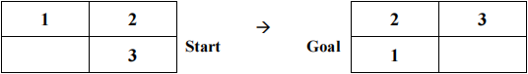

**Figure 1: The Puzzle Problem**

1. Provide the goal formulation of the puzzle problem above. ()
2. Formulate the puzzle problem above by specifying the initial state, successor functions, goal test, step cost, and path cost. ()
3. Perform **breadth-first search** and **depth-first search** on the puzzle problem above. Draw the resulting trees for both. ()

|  |
| --- |
| **Answer:** |

1. **Figure 2** shows a puzzle problem that requires rearrangement of the tiles to transform the order from start to goal state. One is only permitted to slide the empty tile to **down, right, up or left**

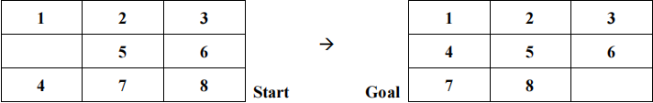

**Figure 2: The 8-Puzzle Problem**

1. Perform **breadth-first search** and **depth-first search** on the 8-puzzle problem above. Draw the resulting trees for both. ()
2. Evaluate the efficiency of **breadth-first search** and **depth-first search** in terms of completeness, optimality, time efficiency and space efficiency in solving the problem above. ()

|  |
| --- |
| **Answer:** |

1. In the family river-crossing problem, two parents are with their two children - a son and a daughter - came to a wide river. The only way to get to the other side was to ask a fisherman if he could lend them his boat. However, the boat could carry only two persons. For safety reason, no child should be left alone without the supervision of at least one parent. The family must get to the other side and finally returns the boat to the fisherman, assuming only the fisherman and the two parents know how to row the boat. Based on this family river-crossing problem, answer the following questions.
2. Suggest a simple representation of the initial state. You must briefly explain the representation. ()
3. Describe the goal formulation and problem formulation: initial state, successor function, step cost, path cost and goal test. ()
4. Draw the depth-first search tree to show how all the states are being traversed. ()

|  |
| --- |
| **Answer:** |

1. **Figure 3** below shows a directed graph. Assume that the traversal would start from **Vertex 0** to **Vertex 7**. All vertices to be visited in **ascending order** (i.e. from smaller number to bigger number).

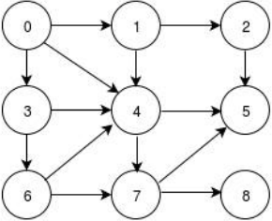

**Figure 3: The Directed Graph**

1. Perform a **depth-first search** on the directed graph to traverse from Vertex 0 to Vertex 7. Draw the resulting tree and list the returned path. ()
2. Perform a **breadth-first search** on the directed graph to traverse from Vertex 0 to Vertex 7. Draw the resulting tree and list the returned path. Avoid repeated state. ()
3. Evaluate the efficiency of **breadth-first search** and **depth-first search** in terms of completeness, optimality, time efficiency and space efficiency in solving the problem above. ()

|  |
| --- |
| **Answer:** |

# Tutorial 4

1. **Figure 1.1** below shows a Block World Problem. A robot will move the blocks one by one from initial state S1 to reach the goal state S19.

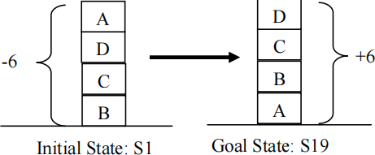

**Figure 1.1**

**Figure 1.2** shows the state space of the Block World Problem and the heuristic costs for each state are shown in parentheses next to their respective nodes.

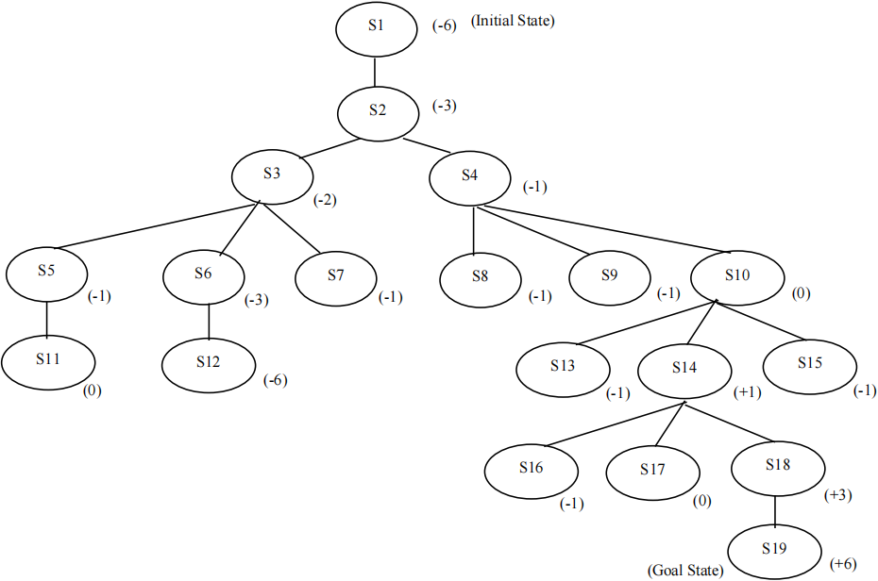

**Figure 1.2**

1. Explain step cost used in problem formulation. Specify the value of the step cost for the problem above. ()
2. Hill climbing search is unable to guarantee completeness and optimality as it may be trapped into local maximum. ()
3. Explain local maximum.
4. Discuss why hill climbing search always lead to a local maximum.
5. Use simple hill-climbing and steepest-ascent hill-climbing to search for the best path from S1 to S19 on the state space shown in **Figure 1.2**. Then for each search technique, draw the resulting search tree that shows the visited nodes. Show that hill-climbing technique can be trapped into a local maximum.
6. A search technique can be evaluated based on four criteria: completeness, optimality, time complexity and space complexity. Evaluate the efficiency of breadth-first search and steepest-ascent hill-climbing. Conclude which technique is better to solve the Block World Problem mentioned in **Figure 1.1**. ()

|  |
| --- |
| **Answer:** |

1. **Figure 2** below shows an 8-puzzle problem, which requires rearrangement of the tiles to transform the order from start state to goal state. One is only permitted to slide the empty tile to **up**, **down**, **right** or **left**. ()

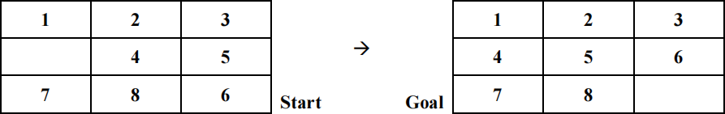

**Figure 2: The 8-Puzzle Problem**

1. Suggest a heuristic function to produce a heuristic cost for a state. Demonstrate how such heuristic cost can be computed on the **start state**. Then perform best-first search.
2. Evaluate the efficiency of **breadth-first search** and **best-first search** in terms of completeness, optimality, time efficiency and space efficiency in solving the problem above.
3. Can hill-climbing find a solution for this problem? Draw a resulting search tree to support your answer.

|  |
| --- |
| **Answer:** |

1. The following graph in Figure 1.1 shows all the nodes in a telecommunication network. The distance (in km) from one node to another is shown on the arc. ()

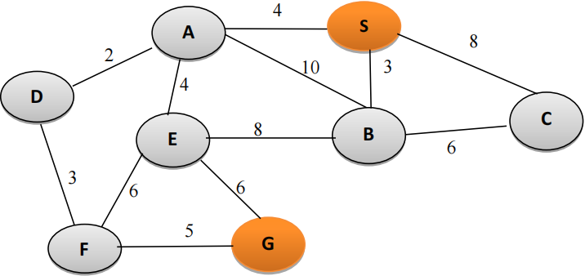

**Figure 3: A search graph of a new LRT network**

The Euclidean distance (in km), which is used as the heuristic cost (h) for different node, is provided in Table 1 below.



1. Assume that some data are to be sent from node S to node G using the shortest route. Describe the goal formulation and problem formulation (initial state, successor function, goal test, step cost and path cost).
2. Show the resulting search tree of A* search to find the shortest path from S to G. State the shortest path. (Remark: Ignore repeated nodes that have been visited previously)
3. Evaluate the efficiency of A* search in solving the path-finding problem above

|  |
| --- |
| **Answer:** |

1. Consider 2 heuristic *h1* and *h2* of A* for the puzzle problem are defined as:

*h1*(*n*) = number of misplaced tiles

*h2*(*n*) = total Manhattan distance

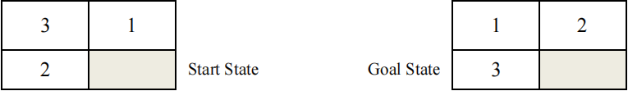

1. Illustrate the **state space** of the puzzle to reach the goal state based on:

* *h1*(*n*) ()
* *h2*(*n*) ()

1. Show the resulting search trees of A* search to find the shortest path using the heuristic functions of:

* *h1*(*n*) ()
* *h2*(*n*) ()

You must clearly show the function cost, given that: *f*(*n*) = *h*(*n*) + *g*(*n*), where *g*(*n*) is the path cost.

|  |
| --- |
| **Answer:** |

# Tutorial 5

* + - 1. Semantic network is a knowledge base that represents semantic relations between concepts in a network. Draw a semantic network for the following facts and relations. ()

|  |
| --- |
| "David and Victoria are the parents of Romeo and Harper. Romeo and Harper are brother and sister. Jane is the child of Romeo, and Jill is the child of Harper. Romeo has a pet called 'Christal,' a British Shorthair. Christal is 2 years old now and has a grey-blue coat, pineapple eyes, and a medium-sized tail." |

|  |
| --- |
| **Answer:** |

* + - 1. How are semantic networks different from Conceptual Graph? Explain your answer with the help of **ONE** (**1**) diagram for each of the methods based on the following statement: ()

**"A cat is on a mat."**

|  |
| --- |
| **Answer:** |

1. The following statements are given.

|  |
| --- |
| Albert is a human.  Pepper is a robot.  The construction of human is biological, while robot is mechanical.  Both human and robot are autonomous system.  The behaviours of autonomous system are mobile and adaptive. |

1. Between semantic network and frames, justify which knowledge representation tool you would use to represent the information above. ()
2. Discuss **ONE** (**1**) limitation of the knowledge representation tool that is selected in Question 3(a) above. ()
3. Illustrate the representation of the given statements above using the knowledge representation tool that you selected in Question 3(a) above. ()

|  |
| --- |
| **Answer:** |

1. The following statements are given.

|  |
| --- |
| Bird is a living being that builds nest.  Insect is an invertebrate living being.  Ant is a kind of insects that builds nest.  Both dragonfly and fly are insects that have wings. |

1. Between semantic network and frames, justify which knowledge representation tool you would use to represent the information above. ()
2. Discuss **ONE** (**1**) limitation of the knowledge representation tool that is selected in Question 4(a) above. ()
3. Illustrate the representation of the given statements above using the knowledge representation tool that you selected in Question 4(a) above. ()

|  |
| --- |
| **Answer:** |

1. Suggest and describe a real-life application where semantic network is applied. ()

|  |
| --- |
| **Answer:** |

1. A rules based heart failure rule-based system is shown below.

R1: IF Blood pressure is higher than 130 mm Hg

THEN Most likely it is hypertension.

R2: IF Cholesterol is higher than 240 mg/dL

THEN Most likely it is high cholesterol.

R3: IF Maximum heart rate is more than 100 beats per minute

THEN It may be Tachycardia.

R4: IF There is hypertension

AND High cholesterol

AND Tachycardia

THEN Most probably the patient is having heart disease.

Proposed **ONE (1)** technique to represent the knowledge above. Then, represent the knowledge by using the proposed technique. ()

|  |
| --- |
| **Answer:** |

1. The information below describes the differences between a desktop and a laptop. Illustrate the information below with frames. ()

*Laptop and desktop are the commonly used computer among students. Laptop is generally small and easily portable. It can run either on battery or main power supply. Desktop, on the other hand, is large and not portable. It only runs on main power supply. Besides that, desktop normally has more powerful processor as compared to laptop. ACER Predator Helios 500, which is a gaming laptop, however, is equipped with a powerful Intel i9 processor.*

|  |
| --- |
| **Answer:** |

# Tutorial 6

1. Discuss the **THREE** (**3**) major obstacles involved in Natural Language Understanding (NLU). ()

|  |
| --- |
| **Answer:** |

1. What are the three typical stages involved in a Natural Language Processing (NLP) application development? Elaborate these three stages with the aid of appropriate diagrams. ()

|  |
| --- |
| **Answer:** |

1. Besides the three main phases involved in NLP as discussed in Question 2, describe three other significant analyses that can be done to improve NLP applications. ()

|  |
| --- |
| **Answer:** |

1. NLP application requires the use of knowledge about human languages. Suggest an example of NLP application and describe the difficulties that a researcher would face during the development of the application that you have suggested. ()

|  |
| --- |
| **Answer:** |

1. In NLP, representation is important as it can solve issues like canonical form of sentences and syntactic problem of a sentence.
2. Explain the meaning of canonical form of sentences. Provide examples to elaborate your answer.
3. By referring to the below statement, there is a syntactic problem. Identify the problem and then draw **TWO** (**2**) different representation (by selecting either the semantic network or the conceptual graph) to solve the syntactic problem. ()

**"Rambo hit the man with a hammer"**

|  |
| --- |
| **Answer:** |

1. Parse tree is a popular tool used in one of the phases of NLP called parsing. ()
2. Explain the importance of parsing in NLP.
3. With the aid from the simple English grammar for simple transitive sentence as shown next page, draw the respective **parse trees** to verify the sentences "**the boy likes the girl**" and "**time flies like an arrow**"

|  |
| --- |
| Sentence -> noun_phrase verb_phrase  Noun phrase -> noun  Noun-phrase -> article noun  Verb phrase -> verb noun_phrase  Verb phrase -> verb preposition noun_phrase  preposition [like]  article [a, an, the]  noun [flies, time, arrow, boy, girl]  verb [like, flies] |

|  |
| --- |
| **Answer:** |

1. Considering the sentence S = "**She beats George with one hand at the bank**".()
2. The sentence S consists of semantic ambiguity and syntactic ambiguity. Identify both of the ambiguities found from the sentence above.
3. Given the grammar below, construct **ONE** (**1**) parse tree for the sentence S. (**Remark**: grammar in the parentheses **()** means it is optional.)

|  |
| --- |
| **S -> NP VP (PP)**  **NP -> (DET) (ADJ) N (PP)**  **VP -> V NP (PP)**  **PP -> P NP**  **ADJ -> [one]**  **DET -> [a, the]**  **N -> [She, George, hand, bank]**  **V -> [beats]**  **P -> [with, at]** |

|  |
| --- |
| **Answer:** |

1. Consider a sentence, *S* = *Ethan invited the person with microphone.* ()
2. The sentence *S* consists of syntactic ambiguity. Identify the ambiguity found from the sentence above.
3. Given the grammar below, construct **ONE** (**1**) parse tree for the sentence *S*.

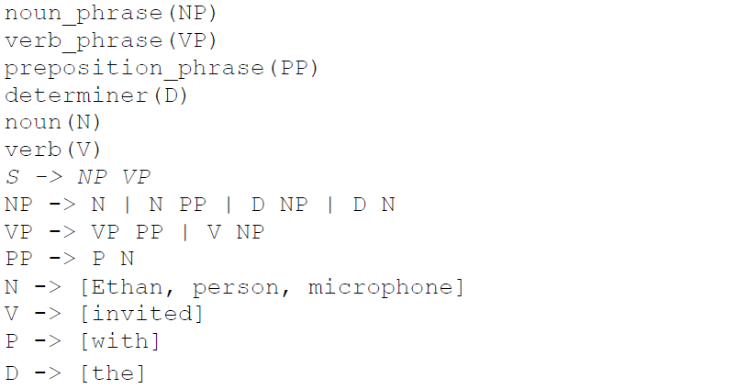

|  |
| --- |
| **Answer:** |

# Tutorial 7

1. Differentiate between artificial intelligence (A.I.) and machine learning (ML). ()

|  |
| --- |
| **Answer:** |

1. There are **TWO** (**2**) main types of ML which are Supervised and Unsupervised Learning. ()
2. Discuss the differences between them.
3. Provide **TWO** (**2**) algorithms for each type ML.

|  |
| --- |
| **Answer:** |

1. Assume that the Sea Fisheries Department has approached you to analyze abalone from physical measurements. A set of data that contains 7 attributes and 4177 rows of records is given. Part of the data are shown in **Table 1** below:

Table 1: Partial Abalone Data*

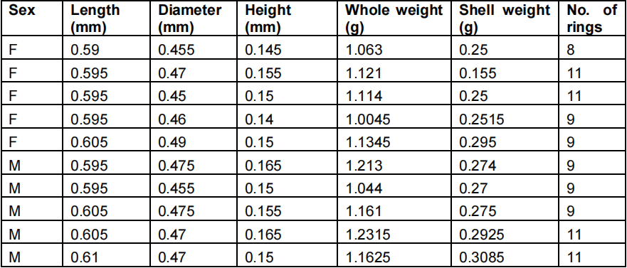

*Data Source: http://mlr.cs.umass.edu/ml/datasets/Abalone*

*Reference: Asuncion, A. & Newman, D.J. (2007). UCI Machine Learning Repository*

*[http://www.ics.uci.edu/~mlearn/MLRepository.html]. Irvine, CA: University of California, School of Information and Computer Science.*

Between supervised learning or unsupervised learning, which type of ML is suitable to perform the following data analytics? Justify your answer. Then suggest **ONE** (**1**) suitable ML algorithm for each case.

1. To determine 3 different grades of abalone based on diameter and whole weight. ()
2. To predict the age of an abalone. (To determine the age of an abalone, we can check the number of rings, which is between 1 to 29) ()

|  |
| --- |
| **Answer:** |

1. K-Nearest Neighbors is used to classify data X into its respective class (Dog, Cat or Bird). Remark: K = 9. ()

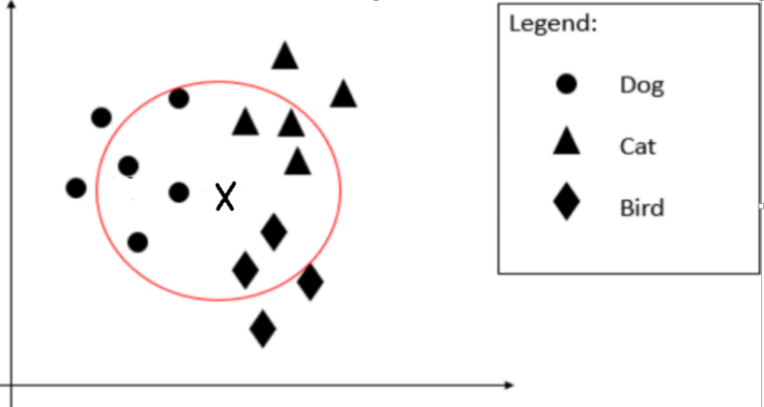

Figure 1: Dataset

1. Compute P (Dog | X), P (Cat | X), and P (Bird | X).
2. Identify which class that X belongs to with explanation.

|  |
| --- |
| **Answer:** |

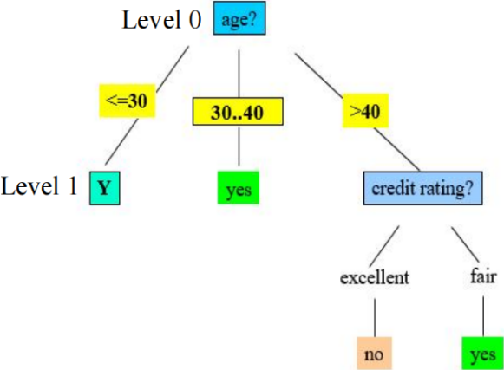

Figure 3: Partial decision tree of buys_computer

Table 2: The decision table of buys_computer

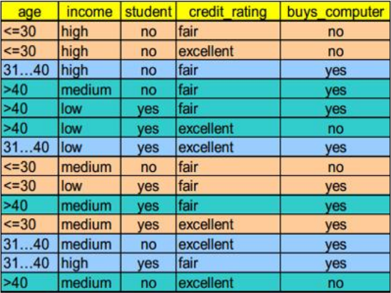

1. Given the table and the corresponding decision tree as above.
2. Determine the appropriate attribute Y (income, student or credit_rating) at level 1 (Figure 3) by using Information Gain. Justify your answer. ()
3. Produce the complete decision tree based on the answer from Question 6(a). ()
4. Given a new sample, X = **<** <=30, low, no, excellent **>**, predict the class it belongs to. ()
5. Refer to **Table 2**, given a new sample, X = **<** <=30, low, no, excellent **>**, predict the class it belongs to, P(C|X), using Naïve Bayes classification. ()

To calculate the information gain:

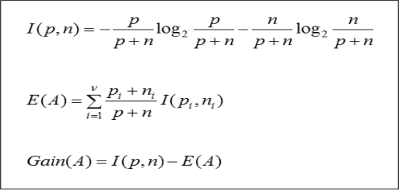

|  |
| --- |
| **Answer:** |

1. Assess the following performance of the classifier as shown in Figure 4:
2. Overall accuracy()
3. Precision for cat classification()
4. Recall for dog classification()

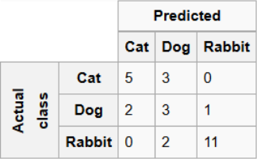

Figure 4: Confusion Matrix

|  |
| --- |
| **Answer:** |

# Tutorial 8

1. Draw a diagram to depict unsupervised learning model. ()

|  |
| --- |
| **Answer:** |

1. Considering a partial dataset as shown in Table 1: ()
2. Explain how regression model is different from clustering.
3. Explain how regression model and clustering can be applied on the dataset below.

Table 1: Sample of data

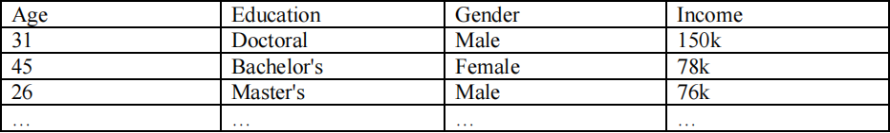

|  |
| --- |
| **Answer:** |

1. Clustering is the grouping of unlabeled data, it can be used for knowledge discovery. Discuss about this and provide **TWO** (**2**) real world applications of clustering. ()

|  |
| --- |
| **Answer:** |

1. K-means is used to cluster the data in Table 2. Randomly we choose two cluster centers (**k = 2**) for two clusters; **C1 = (1.0, 1.0)** and **C2 = (5.0, 7.0)**.

Table 2: Sample of data

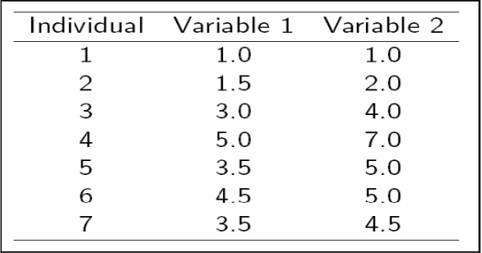

1. List the clusters that each data will be assigned to. ()
2. Identify the new centers for the first iteration. ()
3. Suggest **TWO** (**2**) stopping conditions for K-means. ()
4. Discuss on the limitation of K-means. ()

Try this also: Construct a dendrogram for hierarchical clustering using the dataset from Table 2 using centroid linkage. Additionally, determine the individual data points associated with each cluster when employing a 3-cluster solution ()

|  |
| --- |
| **Answer:** |

1. Mean Shift is one of the popular clustering algorithms: ()
2. Demonstrate the algorithm for Mean Shift
3. Discuss the advantages and disadvantages of Mean Shift.

|  |
| --- |
| **Answer:** |

1. Explain why cluster evaluation is a hard problem. Identify **TWO** (**2**) methods based on internal information that we can use to evaluate a clustering algorithm. ()

|  |
| --- |
| **Answer:** |

# Tutorial 9

1. Answer the following questions:
2. Research in Artificial Neural Networks (ANNs) started with a view of mimicking the functioning of Biological Neural Networks (BNNs). Illustrate with diagrams, how the BNNs and ANNs are similar to each other. ()
3. Figure 1 below shows the simplest neural network model that is known as perceptron, which can be used for classification tasks. Briefly explain the functions of each of the layers A, B and C as shown in the diagram. ()

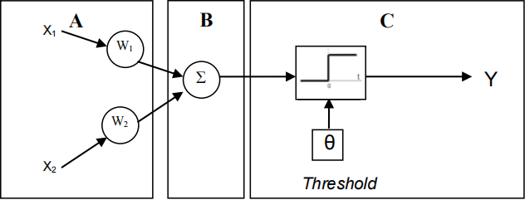

Figure 1: A sample neural network model

1. Back propagation Multilayer Artificial Neural Network can be applied into a system that is able to recognize and interpret two different types of flowers. Discuss the prerequisite for the Neural Network system and design **ONE** (**1**) Neural Network structure for the purpose. State the advantage of back propagation network. ()

|  |
| --- |
| **Answer:** |

1. Assume that the Sea Fisheries Department has approached you to analyze abalone from physical measurements. A set of data that contains 7 attributes and 4177 rows of records is given. Part of the data are shown in Table 1 below:

Table 1: Partial Abalone Data

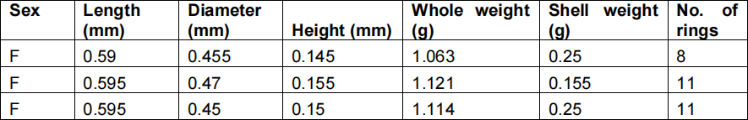

Demonstrate how a **multi-layer feedforward back-propagation neural network** can be constructed to predict the number of rings of abalone. Illustrate the architecture of the neural network with appropriate labels of each layer in the diagram. In your diagram, also include all the attributes and output as shown in Table 1. ()

|  |
| --- |
| **Answer:** |

1. A combinational logic circuit are made up from basic logic AND, OR, NAND, NOR or NOT gates that are “combined” or connected together to produce more complicated switching circuit. The output of the gate will be determined by combination of 1's and 0's which are present at the input terminals. The truth table of 3-input combinational logic circuit is given by Table 2 and Figure 2 where A, B and C are the inputs and Q is the output. ()

Table 2

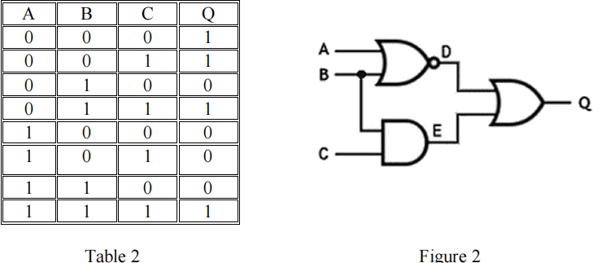



Figure 2

Train the perceptron to perform 3-input combinational logic circuit operation. The formula of output Q is given by

**Q = w1A + w2B + w3C**

where w1, w2 and w3 are weight for A, B and C respectively. Assume that the threshold θ = 0.25, learning rate α = 0.1 and **step function** is used for activation function. Calculate the final weights of w1, w2 and w3 for epoch 1 only. (Assume the initial weights w1 = 0.3, w2 = 0.2 and w3 = 0.1)

|  |
| --- |
| **Answer:** |

1. In a supervised learning session, a 2-input neuron and the respective truth table are given in Figure 3 and Table 3, where x1 and x2 are the inputs and y is the output. ()

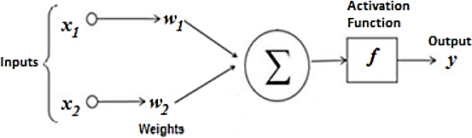

Figure 3: The 2-input neuron

**Table 3**

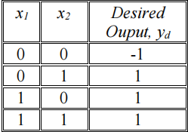

The formula of output y is given by



y = sign(n) =

where n = w1x1 + w2x2 , and w1 and w2 are the weights for x1 and x2 respectively. The sign function is used for activation function. The weights, w1 = 0.1 and w2 = 0.2, the threshold, θ = 0.2 and the learning rate, α = 0.1 are set initially for the training. Train the neuron and demonstrate the final weights of w1 and w2 **for epoch 1 only**.

|  |
| --- |
| **Answer:** |

# Tutorial 10

1. Noise reduction is very important in image processing. ()
2. Discuss the above statement.
3. Identify **TWO** (**2**) types of noises in an image.
4. Name a filter to perform noise reduction.
5. Demonstrate how image filtering works in reducing the noise by using median filter.

|  |
| --- |
| **Answer:** |

1. Morphological operation is important in image processing. ()
2. Explain **FOUR** (**4**) morphological operations.
3. Suggest a morphological operation that could be used to recover the image as shown in figure below (the objective is to close the gap between the pixels of the number). Explain your answer.

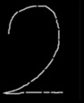

|  |
| --- |
| **Answer:** |

1. Explain **ONE** (**1**) importance of morphological image analysis in image processing. ()

|  |
| --- |
| **Answer:** |

1. In morphological image analysis, morphological operators often probe an image with a **structuring** element. A 6x6 image is given in **Figure 1** below. (Note: Replace the pixel value to 0 for border problem due to not enough neighbouring pixels to perform the filtering)

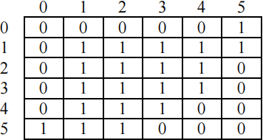

Figure 1: 6x6 binary image

1. Based on the 3x3 structuring element with the origin in the middle as shown in Figure 2, perform an erosion effect on the 6x6 binary image as shown in Figure 1. Provide the resulting binary image. ()

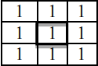

Figure 2: 3x3 square structuring element

1. Based on the 2x2 structuring element with the origin in the middle as shown in Figure 3, perform an dilation effect on the 6x6 binary image as shown in Figure 1. Provide the resulting binary image. ()



Figure 3: 2x2 square structuring element

|  |
| --- |
| **Answer:** |

1. The scanned document in Figure 4 shows a missing portion of pixels (with an actual value of 2) resulting from a poor scanning process. Figure 5 represents the pixel value of Figure 4. Utilising the structuring element depicted in Figure 5, apply both dilation and erosion operations to Figure 5. Then, develop a resulting complete pixel for each operation. The origin of the structuring element is denoted by the bold box in Figure 6. Also, conclude which technique is more suitable to restore the missing part of the Figure 4. (Note: Replace the pixel value to 0 for border problem due to not enough neighbouring pixels to perform the filtering) (Assign 2 students)

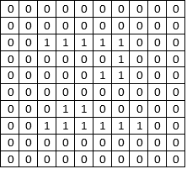 

Figure 4: Scanned image Figure 5: Pixel value

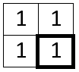

Figure 6: Structuring element

|  |
| --- |
| **Answer:** |

1. Pre-processing is one of the important steps in digital image analysis. ()
2. Explain the importance of image pre-processing.
3. Identify the suitable pre-processing operations based on the images in **Figure 7**. Provide brief description for each of the suggested operations.

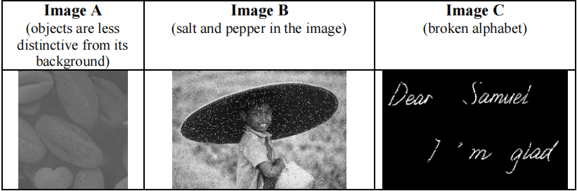

Figure 7: Sample images

|  |
| --- |
| **Answer:** |

1. Figure below shows a part of scanned image which will be recognized by optical character recognition (OCR) algorithm. Nevertheless, the detection performance is relatively poor compared to the actual sentence “Tbis page ccntains of 5 Questions.” Identify TWO (2) potential output error produced by OCR algorithm. In an addition, provide ONE (1) preprocessing technique to increase the accuracy of OCR performance for each potential output error. ()



# Tutorial 11

**Part I: Expert Systems**

1. Given a customer has problem deciding whether or not to purchase a car. He consulted an expert for advice and the consultant suggested some rules as follows.

Rule 1: IF The condition of car is poor

OR The price of the car is high

THEN Don't buy the car

Rule 2: IF Mileage on the car exceeds 100,000

AND The car is city driven

AND The body of the car is bad

THEN The condition of the car is poor

Rule 3: IF The car has dents

THEN The body of the car is bad

Rule 4: IF The car has rust

THEN The body of the car is bad

1. Assume the hypothesis is "Don’t buy the car", draw an inference network (and-or graph) that supports the problem above. ()
2. Given the observation by the expert as follows, demonstrate the inference process by using forward-chaining. ()

|  |
| --- |
| Mileage: 160,000 miles  Location of car: KL city  Dents on car: right rear door and back door  Rust on car: not noticed  Price of car: $1000 (remark: considered low) |

1. If you are going to develop the above expert system, which inference mechanism are you going to implement? Forward or backward chaining? Justify your answer. ()

|  |
| --- |
| **Answer:** |

1. A basic structure of a rule-based expert system involves the components such as knowledge base, database, inference engine, explanation facilities, user interface, and user. ()
2. Draw a diagram to illustrate the relations between the components in an expert system as given above, and describe the functions of each component.
3. Define the fundamental characteristics of an expert system.
4. What is the reason that an expert-system separates its knowledge base from the inference mechanism in the system?

|  |
| --- |
| **Answer:** |

1. Given the rules below:

|  |
| --- |
| R1: If X breathes using gills  Then X lives in sea |
| R2: If X has backbone and has fin and breathes using gills  Then X is fish |
| R3: If X lives in sea and has backbone and has fin  Then X is seahorse |
| R4: If X is fish and has fin and has two eyes at two sides  Then X is shark |
| R5: If X is fish and has two eyes at one side  Then X is flounder |

A subject with ID "X1001" was observed and some facts were gathered as listed below:

* X1001 has backbone
* X1001 has fins
* X1001 breathes through gills
* X1001’s two eyes on two sides of its head

1. From the observation above, conflicts may occur when you infer the rules above. Analyze what is the potential conflict that might occur. ()
2. Suggest and discuss **THREE** (**3**) approaches of conflict resolution. ()
3. Derive a conclusion for the problem above for each of the conflict resolution approaches that you have suggested in Question 3(b) by using forward chaining. ()

|  |
| --- |
| **Answer:** |

**Part II: Recommender Systems**

1. There are two common types of recommendation engine algorithms, i.e. collaborative filtering models and content-based models. Briefly explain the differences between them. Provide examples of applications to aid your answers. ()

|  |
| --- |
| **Answer:** |

1. Discuss the limitations of collaborative filtering models. ()

|  |
| --- |
| **Answer:** |

1. Discuss the limitations of content-based models. ()

|  |
| --- |
| **Answer:** |

1. There are two types of collaborative filtering models as follows. Differentiate these two types with the aid of suitable examples. ()
2. user-user
3. item-item

|  |
| --- |
| **Answer:** |

# Tutorial 12

**Part I: Probability Theory**

1. **FOUR** (**4**) of the rules in a rule-based system are given as follows:

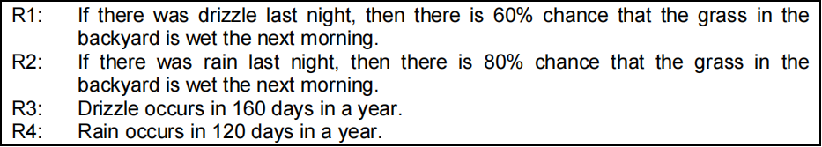

Assume that the drizzle and rain occur exclusively, and there are 365 days in a year.

1. Specify the above rules in probability assertion. ()
2. If you see the grass in the backyard is wet in the morning, by using Bayes Theorem, what is the event that most probably occurred last night? ()
3. After a conclusion is drawn from Question 1(b), your grandfather asserts that sometimes your neighbour would spray water in the backyard at night. ()
4. Do you think this assertion would affect the conditional probability?
5. Do you think this assertion would affect your initial conclusion as well?

Explain your answers.

|  |
| --- |
| **Answer:** |

1. Part of the rules in a liver disease diagnosis system is shown below. ()

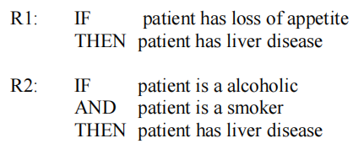

Considering only the following information is given to you.

1. P( patient has loss appetite | patient has liver disease) = 0.8
2. P(patient has liver disease) = 0.00013

Assume that a patient rated that he has loss appetite 70% of the time, demonstrate how do you predict P(patient has liver disease | patient has loss appetite) using Naïve Bayes Algorithm.

|  |
| --- |
| **Answer:** |

1. A police officer sees you run a red light late one Saturday night. Before pulling you over, the officer tries to guess what caused you to run the red light and comes up with the following possibilities:
2. You are drunk
3. You are in a hurry
4. You are not wearing your glasses
5. You felt you could do it and get away with it

The policeman assigns the following evidential probabilities to these hypotheses given that the incident happened late on a Saturday night

* P(run light late Sat. night | drunk driver) = 0.45
* P(run light late Sat. night | driver in a hurry) = 0.60
* P(run light late Sat. night | driver didn’t see light) = 0.15
* P(run light late Sat. night | didn’t see cop/thinks can get away with it) = 0.05

He further assigns the following prior probabilities:

* P(drunk driver) = 0.10
* P(hurried driver) = 0.33
* P(driver not wearing glasses) = 0.10
* P(driver feels he can get away with things) = 0.25

Compute the conditional probabilities for the four possibilities. What decision is the police officer most likely to make? ()

|  |
| --- |
| **Answer:** |

**Part II: Certainty Factor**

1. You receive a phone call from your classmate, James, informing you that your name is in the pass list. Preparing to tell your parents the good news, you recall that James is a liar who loves to play jokes on others. Thus, you decide to call another classmate, Sean. Although Sean is known for being occasionally careless, you believe that Sean is far more reliable. ()

|  |
| --- |
| If James’ call is true, then there is a 0.5 certainty that your name is in pass list.  If Sean’s call is true and Sean is not careless is true, then there is a 0.9 certainty that your  name is in the pass list.  If your name is in the pass list, then there is a 0.99 certainty that you pass the examination.  The certainty of James’ call is 1.0.  The certainty of Sean’s call is 1.0.  The certainty of Sean is not careless is 0.5 |

Based on the information provided, would you pass the examination?

|  |
| --- |
| **Answer:** |

1. Assume that a simple inference system is built using certainty factors. Demonstrate how to compute the certainty factor that a patient has liver disease based on the following rules. ()

|  |  |  |
| --- | --- | --- |
| R1:  R2: | IF  THEN  IF  AND  THEN | patient has loss of appetite [CF 0.7]  patient has liver disease [CF 0.5]  patient is a alcoholic [CF 0.8]  patient is a smoker [CF 1.0]  patient has liver disease [CF 0.9] |

Combining Certainty Factors:

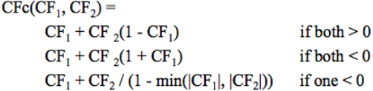

|  |
| --- |
| **Answer:** |

1. The Ebola outbreak has raised concerns of international spread in 2014, similar to the SARS epidemic in more than 10 years ago. Assume that you are assisting a medical centre to develop an online expert system that consults people on recognizing the symptoms of these diseases. Part of the rules of the system is as follows: ()

|  |  |  |
| --- | --- | --- |
| R1:  R2:  R3:  R4:  R5:  R6:  R7: | IF  AND  THEN  IF  THEN  IF  THEN  IF  THEN  IF  AND  THEN  IF  AND  THEN  IF  AND  THEN | body temperature exceeds 37 °C  headache presents AND muscle aches presents  fever presents (CF 0.8)  body temperature exceeds 37 °C  fever presents (CF 0.2)  body temperature exceeds 38 °C  fever presents (CF 1.0)  cough presents AND fever presents  symptom of SARS (CF 0.5)  cough presents AND cough starts 2-3 days after other symptoms  fever presents  symptom of SARS (CF 0.6)  IF (cough presents OR nausea presents OR stomach pain presents)  fever presents  symptom of Ebola (CF 0.5)  IF cough presents AND nausea presents AND stomach pain presents  fever presents  symptom of Ebola (CF 0.8) |

John has recently returned from oversea and he started to show the following symptoms. Based on R1 to R7, demonstrate the inference steps and conclude what disease that John could be infected.

|  |  |
| --- | --- |
| Body temperature exceeds 37 °C  Headache presents  Muscle aches presents  Body temperature exceeds 38 °C  Cough presents  Cough starts 2-3 days after other symptoms  Nausea presents  Stomach pain presents | CF = 1.0  CF = 1.0  CF = 1.0  CF = 1.0  CF = 1.0  CF = 0.8  CF = 0  CF = 0.9 |

Remark: To calculate a combined certainty factor, use the following equation:



|  |
| --- |
| **Answer:** |

1. Given the report of an observation at 7am as below, demonstrate the inference and conclude the weather of tomorrow based on certainty factors. ()

|  |
| --- |
| Place of observation: Miami, Florida (tropical climate) (CF=1)  Observation data:   * Cloud height > 18,000 feet (CF = 0.8) * Clouds are small, rounded puffs, appeared in long rows. (CF=0.8) * Cloud patterns are sheet-like. (CF = 0.2) * Color of cloud is white. (CF=0.7) * Sun can shine through. (CF=0.9) * Humidity: warm and sticky (CF=0.7) |

Remark: The certain factor (CF) for other unknown data is 0.

|  |  |  |  |
| --- | --- | --- | --- |
| IF  THEN  IF  THEN | Cloud_Height > 18,000 feet [P1.1]  Cloud_Group is Cirrus [H1] (CF= 0.8)  Cloud_Height is between 6,500 feet to 18,000 feet [P2.1]  Cloud_Group is Alto [H2] (CF=0.8) | | |
| IF  AND  AND  AND  THEN  IF  AND  AND  THEN  IF  AND  AND  THEN  IF  AND  THEN | Cloud_Group is Cirrus [P3.1]  Cloud_Pattern is sheet-like [P3.2]  Cloud_Color is white [P3.3]  Moon or Sun can shine through [P3.4]  Cloud_Type is Cirrostratus [H3] (CF=0.8)  Cloud_Group is Cirrus [P4.1]  Cloud_Pattern is small, rounded puffs with long rows [P4.2]  Cloud_Color is white or gray [P4.3]  Cloud_Type is Cirrocumulus [H4] (CF=0.8)  Cloud_Group is Alto [P5.1]  Cloud_Color is gray or blue gray [P5.2]  Moon or Sun can shine through [P5.3]  Cloud_Type is Altostratus [H5] (CF=0.7)  Cloud_Group is Alto [P6.1]  Cloud_Color is gray [P6.2]  Cloud_Type is Altocumulus [H6] (CF=0.8) | |
| IF  THEN  IF  AND  THEN  IF  AND  THEN  IF  THEN  IF  AND  THEN | Cloud_Type is Cirrostratus [P7.1]  Rain or snow storm occurs within 12-24 hours [H7] (CF=0.7)  Cloud_Type is Cirrocumulus [P8.1]  Climate_Zone is NOT of Tropical [P8.2]  Weather is fair but cold [H8] (CF=0.7)  Cloud_Type is Cirrocumulus [P9.1]  Climate_Zone is of Tropical [P9.2]  Hurricane is approaching [H9] (CF=0.6)  Cloud_Type is Altostratus [P10.1]  Storms with continuous rain or snow is reaching [H10] (CF=0.7)  Cloud_Type is Altocumulus [P11.1]  Morning is warm and sticky [P11.2]  Thunderstorms by late afternoon [H11] (CF=0.7) |

**Part of the rules in the expert system (Reference: boatsafe.com)**

|  |
| --- |
| **Answer:** |

# Tutorial 13

1. Following shows a sample crisp rule. ()

|  |
| --- |
| IF temperature > 37.5  THEN fever = TRUE |

1. Explain the difference between crisp rule and fuzzy rule.
2. Suggest how do you convert the crisp rule above into a fuzzy rule.
3. Design the appropriate fuzzy sets to represent the input and output variables respectively.

|  |
| --- |
| **Answer:** |

1. Illustrate the general structure of Fuzzy Inference System and explain each of the components. ()

|  |
| --- |
| **Answer:** |

1. Assume that you are designing an automated air conditioning system using Fuzzy Logic. ()
2. Suggest an uncertainty in the above scenario with explanation.
3. Generate the **TWO** (**2**) input and **TWO** (**2**) output fuzzy membership functions that are able to model the air conditioning system.
4. Suggest **TWO** (**2**) fuzzy rules that associate to the Fuzzy membership functions generated in Question 3(b).

|  |
| --- |
| **Answer:** |

1. Suppose you are designing a fuzzy thermostat with the following membership function of the temperature. ()

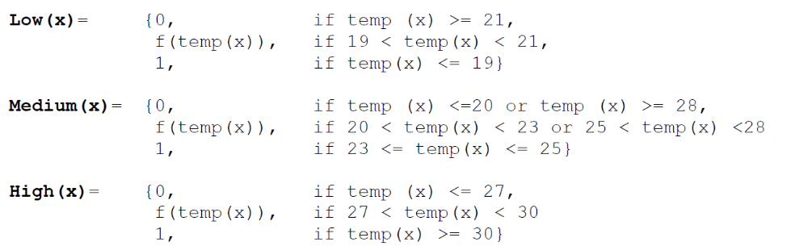

1. Illustrate the graph with labels to represent the above membership function.
2. Propose **ONE (1)** fuzzy rule that can be used in the fuzzy thermostat.

|  |
| --- |
| **Answer:** |